Bahria University,

Karachi Campus



LAB EXPERIMENT NO.

**04**

LIST OF TASKS

|  |  |
| --- | --- |
| TASK NO | OBJECTIVE |
| 1 | **List the names of files in a directory with their size** |
| 2 | **Write the program to rename the directory.** |
| 3 | **Create a directory with Create Directory () function after that create file inside this directory, then open the file.** |

Submitted On:

**28/10/2022**

**Task # 01: List the names of files in a directory with their size**

**Solution:**

#include<iostream>

#include<dirent.h>

#include<fstream>

#include <stdio.h>

using namespace std;

long int findSize(char file_name[])

{

    // opening the file in read mode

    FILE* f = fopen(file_name, "r");

    // checking if the file exist or not

    if (f == NULL) {

        // printf("File Not Found!\n");

        return -1;

    }

    fseek(f, 0L, SEEK_END);

    // calculating the size of the file

    long int rest = ftell(f);

    // closing the file

    fclose(f);

    return rest;

}

int main()

{

    struct dirent *d;

    DIR *dir;

    dir = opendir(".");

    if(dir!=NULL)

    {

        cout<<"List of Files & Folders:-\n";

        for(dr=readdir(dir); dr!=NULL; dr=readdir(dir))

        {

            char* name=dir->dir_name;

            // cout<<<endl;

            char file_name[] = { *name };

            long int rest = findSize(name);

            if (rest != -1)

            printf("%s \t\t\t %ld Bytes \n",name, rest);

        }

        closedir(dir);

    }

    return 0;

}

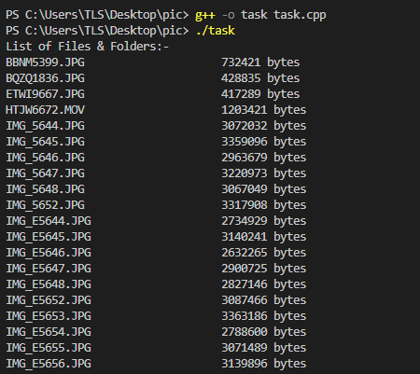**Output:**

**Task # 02: Write the program to rename the directory.**

**Solution:**

#include<stdio.h>

    #include<fstream>

    #include<iostream>

    using namespace std;

    int main()

    {

        char Lastname[] = "Dir";

        char Newname[] = "New_Dir";

        if (rename(Lastname, Newname) != 0){

            perror("Error renaming file");

        }

        else{

            cout << "file renamed Successfully";

        }

        return 0;

    }

**Output:**

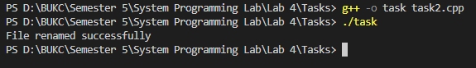

**Task # 03: Create a directory with CreateDirectory() function after that create file inside this directory, then open the file.**

**Solution:**

    #include<iostream>

#include<direct.h>

#include<fstream>

using namespace std;

int main(){

     if(mkdir("New_Folder") == -1) {

        cout << " Not Ble To Create Folder" ;  }

    else  {

        cout << "Folder Created Successfully\n";

        ifstream myfile;

        cout<<"Enter filename:\n";

        string Name;

        cin>>Name;

        myfile.open("D:\\BUKC\\Semester 5\\System Programming Lab\\Lab 4\\Tasks\\New_Folder\\"+ name);

        if(myfile){

            cout<<"****File Exists****";

        }

        else{

            ofstream My_File("New_Folder\\"+name);

            My_File << " Creating Files Is Happy For Us";

            My_File.close();

            cout<<"File Created Successfully!";

        }

    }

    return 0;

}

**Output:**

